ENERGY CONSERVATION ASSIGNMENT

# Assessing India's 2023 Energy Policy Landscape

Submitted By: Shaurya Srinet - RA2111032010006 Shounak Chandra - RA2111032010026

**TABLE OF CONTENTS**

i

|  |  |  |
| --- | --- | --- |
| **S. No** | **TITLE** | **PAGE NO** |
| 1 | ABSTRACT | 1 |
| 2 | INTRODUCTION | 2 |
| 3 | CHALLENGES IN ENERGY CONSERVATION | 3 |
| 4 | RENEWABLE ENERGY | 4 |
| 5 | LITERATURE REVIEW | 6 |
| 6 | OBSERVATIONS | 8 |
| 7 | CONCLUSION | 10 |
| 8 | REFERENCES | 11 |

**ABSTRACT**

The analysis of the changing energy landscape in India indicates a shift brought about by the country's rising energy consumption, the growing importance of renewable energy sources, and growing worries about energy security. A number of strategic policies, plans, and initiatives have been put in place by the Indian government with the intention of encouraging energy conservation, improving energy efficiency, and hastening the use of renewable energy sources. Important facets of India's energy environment are highlighted in the abstract, such as the country's aggressive goals for net-zero emissions and non-fossil capacity. It also highlights how far the country has come in surpassing its COP 21 obligations and how much money it has invested in non-fossil fuels, especially in the field of renewable energy. India's accomplishments in renewable energy, such as the rise in solar and wind power, are highlighted, as is its capacity to use hydropower and solar resources for sustained energy generation. It discusses the government's efforts to promote energy efficiency, such as the Energy Conservation Building Code, and explores the financial side of these policies, including subsidies for renewable energy, fossil fuels, and electric cars. It provides a thorough overview of India's innovative path toward a clean energy future, one that is fueled by the country's diverse approaches to energy security, economic growth, environmental sustainability, and energy policy.

1

# INTRODUCTION

India, renowned for its economic dynamism, stands as one of the world's fastest-growing economies. In response to the ever-increasing demand for energy, the imperative of energy security, and the global transition towards cleaner energy sources, the Indian government has initiated a comprehensive set of policies, targets, and schemes. These measures are meticulously designed to promote energy conservation, enhance energy efficiency, and facilitate the integration of renewable energy into the nation's power matrix.

The overarching goal of these initiatives is two-fold: to advance economic development and enhance energy security, ensuring access to energy while simultaneously curbing carbon emissions to combat climate change. This report seeks to provide an in-depth analysis of the Indian government's energy-related policies, their associated targets, and the implementation of schemes designed to drive energy conservation, boost energy efficiency, and usher in a renewable energy era.

Additionally, this report will delve into the financial dimensions of these policies, examining their influence on the energy sector's development, the direction of private sector investments, energy access, and the broader economic costs and benefits for the people of India. Through this comprehensive analysis, we aim to provide a holistic understanding of India's remarkable journey towards a sustainable and efficient energy future.

2

# CHALLENGES IN ENERGY CONSERVATION

* **Capital Costs:** One of the primary challenges is the initial investment required for energy- efficient technologies and practices. Many industries, especially small and medium-sized enterprises, may face financial constraints.
* **Technological Barriers:** Some industries may lack access to or knowledge about advanced energy-efficient technologies. Overcoming technological barriers often requires capacity building and technology transfer.
* **Data Availability and Management:** Proper data collection, management, and analysis are essential for energy conservation efforts. The lack of accurate energy consumption data can hinder decision-making.
* **Behavioral and Organizational Challenges:** Resistance to change, lack of awareness, and inadequate commitment to energy conservation at the organizational level can be hurdles to implementation.
* **Policy and Regulatory Challenges:** While policies and regulations exist to promote energy conservation, the effectiveness of their implementation can vary. Consistent enforcement and alignment with industry needs are critical.
* **Energy Price Volatility:** Fluctuations in energy prices can affect the motivation for energy conservation efforts. Stable and predictable energy prices are often more conducive to investment in energy-efficient technologies.

Energy conservation in industries in India is a complex and multifaceted endeavor. While there are numerous best practices to follow, overcoming the challenges associated with financial constraints, technology adoption, and policy implementation is crucial. India's industrial landscape is continuously evolving, and government initiatives, such as the Perform, Achieve and Trade (PAT) scheme, aim to address these challenges and promote energy conservation. Industries that successfully implement energy conservation practices not only reduce their operating costs but also contribute to India's broader energy and environmental goals.

3

# RENEWABLE ENERGY PROMOTION

* **Rapid Solar Capacity Expansion:** The National Solar Mission has been successful in rapidly expanding India's solar energy capacity. Since its inception, India's solar capacity has grown significantly. By 2022, India surpassed its target of achieving 100 GW of solar capacity, and the country continues to add solar installations at an impressive rate.
* **Reduced Solar Energy Costs:** The mission has played a crucial role in driving down the cost of solar power generation. Solar tariffs have reached record lows in India, making solar energy competitive with conventional sources. This has not only benefited the energy sector but also end-users, including households and industries.
* **Promotion of Solar Manufacturing:** The mission has encouraged the growth of solar manufacturing in India. To reduce dependence on imported solar panels and components, various incentives and subsidies have been provided to domestic solar equipment manufacturers, fostering a self-sustaining solar ecosystem.
* **Grid Integration and Energy Storage:** Progress has been made in grid integration, enabling a smoother flow of solar energy into the national grid. Additionally, there has been a focus on energy storage solutions, including batteries, to ensure a stable and consistent power supply.
* **Distributed Solar Power:** The mission has emphasized the adoption of distributed solar power, encouraging solar installations on rooftops and unused land. This approach has the potential to transform the energy landscape and reduce transmission losses.
* **Off-Grid Solar Initiatives:** Apart from grid-connected solar power, the mission has supported off-grid solar initiatives. These include solar pumps for irrigation, solar lanterns for rural households, and micro-grids in remote areas, contributing to rural electrification.
* **Green Jobs Creation:** The rapid growth of the solar sector has led to the creation of numerous jobs, particularly in the manufacturing, installation, and maintenance of solar equipment and infrastructure. The solar industry has become a source of employment for a significant portion of the population.

4

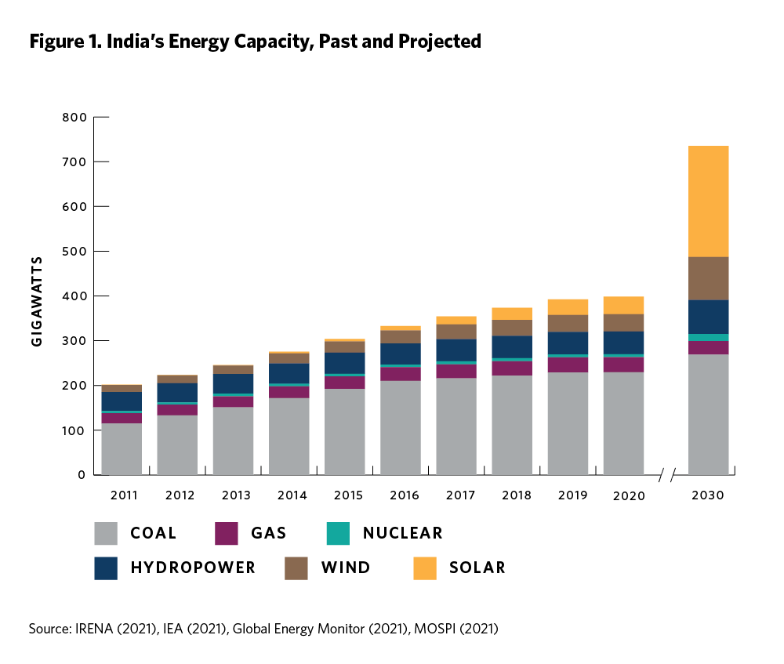

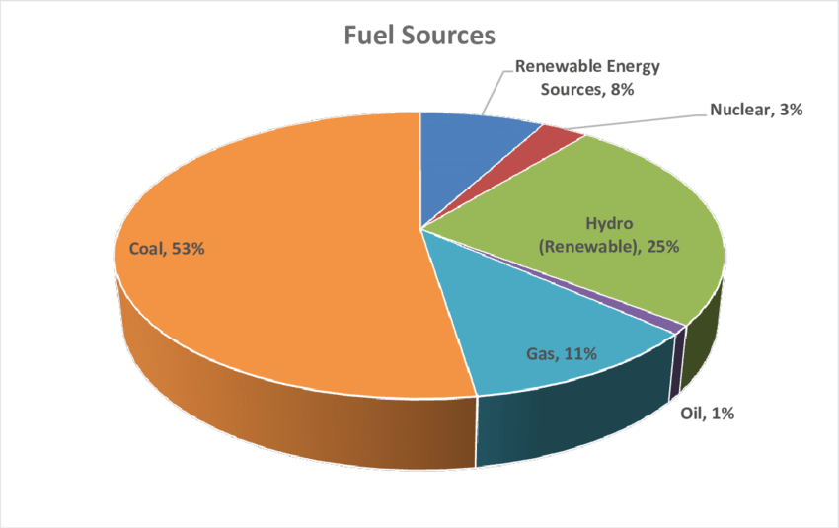

5

# LITERATURE REVIEW

Energy efficiency in residential and commercial buildings is a growing priority in India due to the potential for substantial energy savings and reduced environmental impact. As trends continue to favor green building practices, the nation faces challenges related to awareness, affordability, and retrofitting. Government initiatives, along with increased consumer education and incentives, play a crucial role in furthering energy efficiency in buildings and achieving a sustainable and energy- efficient urban landscape. initiatives for Energy efficiency and Energy conservation taken by Government of India through Bureau of Energy Efficiency (BEE), Ministry of Power.

6

|  |  |  |
| --- | --- | --- |
| **Perform, Achieve and Trade**  **(PAT) Scheme** | **Standards & Labeling**  **Program** | **National Mission for Enhanced**  **Energy Efficiency (NMEEE)** |
| The Perform, Achieve, and Trade (PAT) scheme is a market-based mechanism introduced by the Bureau of Energy Efficiency (BEE) under the National Mission for Enhanced Energy Efficiency (NMEEE). Its primary goal is to improve energy efficiency in energy-intensive industries and designated consumers. | The Standards & Labeling Program (SLB) is another critical initiative under the Bureau of Energy Efficiency (BEE). It focuses on improving the energy efficiency of appliances and equipment used in residential, commercial, and industrial sectors. | The National Mission for Enhanced Energy Efficiency (NMEEE) is a comprehensive initiative launched in 2010 as one of the eight national missions under the National Action Plan on Climate Change. NMEEE encompasses various programs, including the PAT and SLB. It focuses on energy efficiency and conservation across different sectors |
| Compliance: Designated consumers, which include large industries and commercial establishments, are required to achieve energy savings equal to or more than their specific targets. | Minimum Energy Performance Standards (MEPS): MEPS are defined for various appliances to ensure that the least efficient models are phased out from  the market. | Energy Efficiency Financing Platform (EEFP): EEFP facilitates financing for energy efficiency projects in both the public and private sectors, overcoming financial barriers that hinder energy efficiency.  investments. |

|  |  |  |
| --- | --- | --- |
| Trading of Energy Savings Certificates (ESCerts): If a designated consumer exceeds its energy-saving target, it earns ESCerts. These certificates can then be traded on the market. Underperforming entities can purchase ESCerts to meet their compliance requirements. | Consumer Awareness: SLB promotes consumer awareness about energy- efficient appliances and their long-term cost savings. It encourages consumers to choose products with higher star ratings.  7 | Framework for Energy Efficient Economic Development (FEEED) integrates energy efficiency into the development process, ensuring economic development plans and policies incorporate energy efficiency as a key component for sustainable growth. |

# OBSERVATIONS

We now know about important projects and activities that support energy efficiency, conservation, and the use of renewable energy sources in the Indian setting.

1. In India, PAT is a market-based system designed to increase energy efficiency in companies that use a lot of energy. It establishes energy-saving goals for specific customers in industries such as steel, textiles, cement, and so on. Businesses who surpass their goals are awarded Energy Savings Certificates (ESCerts), which are exchangeable on the market and provide cash incentives for energy conservation.
2. Standards & Labeling Program (SLB) is concerned with improving the energy efficiency of equipment and appliances used in a variety of industries. Appliances must have labels on them that show their energy efficiency ratings. Appliances must meet Minimum Energy Performance Standards (MEPS) in order to gradually phase out less efficient products. By promoting the use of energy-efficient goods, SLB raises consumer knowledge and contributes to the reduction of power use.
3. Under the National Action Plan on Climate Change, NMEEE is a comprehensive strategy that includes a range of energy saving activities. Its objectives are to change markets, make it easier to finance energy-saving initiatives, and include energy efficiency into strategies for economic growth.
4. In India, a regulatory system known as Renewable acquire Obligations (RPOs) requires some corporations, particularly electrical distribution firms, to acquire a predetermined amount of their power from renewable sources. They promote energy security, lower carbon emissions, and the use of renewable energy sources.

8

1. We have learned about the many incentives and subsidies that are available in India to encourage the use of solar and wind energy. These include Feed-in Tariffs (FiTs), Generation-Based Incentives (GBI), Investment Tax Credits (ITC), and others. The financial viability and accessibility of renewable energy solutions are greatly aided by these incentives.

Together, these projects and activities propel India's efforts in the direction of a more sustainable and energy-efficient future. They support the use of renewable energy sources, cut carbon emissions, and lessen energy consumption, all of which are in line with India's energy and environmental objectives.

9

# CONCLUSION

India's energy transformation is a testament to the nation's commitment to sustainable development, energy security, and climate responsibility. The government's policies, targets, and schemes have laid a strong foundation for a cleaner, more efficient energy landscape.

With aggressive targets like 500 GW of non-fossil capacity by 2030 and a commitment to achieve net-zero emissions by 2070, India is not merely following global environmental agendas but leading the way. The nation has already exceeded its COP 21 commitments, with 40% of its power capacity now sourced from non-fossil fuels.

Renewable energy has seen remarkable growth, making India a global leader in both capacity and generation. Solar and wind energy have expanded substantially, driven by government policies and initiatives.

Energy efficiency measures, including the Energy Conservation Building Code and annual awards, reflect India's dedication to reducing energy consumption while meeting the growing energy demands of its population.

Financially, subsidies and incentives play a pivotal role in shaping the energy landscape. The government's support for renewables, electric vehicles, and conservation underscores its commitment to clean energy.

In summary, India's journey toward renewable energy is not only significant but inspiring. The government's policies prioritize economic development, energy security, and environmental preservation, setting a precedent for other nations. As India continues to invest in clean energy, it is poised to achieve its energy goals while contributing to global efforts to combat climate change.

10

# REFERENCES

1. "Mapping India's Energy Policy 2022 Update," International Institute for Sustainable Development, [Online].

Available: <https://www.iisd.org/story/mapping-india-energy-policy-2022-update>.

1. "India's Clean Energy Transition Is Rapidly Underway, Benefiting the Entire World,"International Energy Agency, [Online]. Available:htt[ps://www.iea.org/comm](http://www.iea.org/commentaries/india-s-clean-energy-transition-is-rapidly-underway-)e[ntaries/india-s-clean-energy-transition-is-rapidly-underway-](http://www.iea.org/commentaries/india-s-clean-energy-transition-is-rapidly-underway-) benefiting-the-entire-world.
2. "India - Policies & Actions," Climate Action Tracker, [Online] Available: https://climateactiontracker.org/countries/india/policies-action/.
3. "Energy Efficiency," Ministry of Power, Government of India, [Online]. Available: https://powermin.gov.in/en/content/energy-efficiency.
4. "Energy Policy of India," Wikipedia, [Online]. Available: <https://en.wikipedia.org/wiki/Energy_policy_of_India>.
5. Energy Efficiency | Government of India | Ministry of Power. (n.d.). Available: https://powermin.gov.in/en/content/energy-efficiency

11